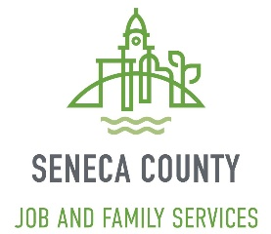 PREVENTION, RETENTION & CONTINGENCY (PRC)

VEHICLE REPAIRS – AUTHORIZED VENDOR LIST

Vehicle Repair Facility | Address | Phone Number
- Fitch’s Auto Repair | 1089 S. Morgan Avenue  Tiffin, OH 44883 | 419-443-1966
- Frankart’s Quality Auto Repair | 4720 S. County Road 591  New Riegel, OH 44853 | 419-595-2102
- Holman’s Garage | 354 W. South Street  Fostoria, OH 44830 | 419-435-3548
- Kelly’s Auto Repair | 31 Allen Street  Tiffin, OH 44883 | 419-448-1282
- Mason’s Automotive | 1105 N. Main Street  Fostoria, OH 44830 | 419-619-0393
- Mike’s Stop Shop | 895 S. Bon Aire Avenue  Tiffin, OH 44883 | 419-443-1160
- Reineke Tiffin Ford | 2020 W. State Route 18  Tiffin, OH 44883 | 419-447-9752
- RR&D Master Automotive Care | 11881 W. Township Road 41  Fostoria, OH 44830 | 419-435-2499

Revised: 12.19.19

